Year 11 Methods– Glossary
This glossary is provided to enable a common understanding of the key terms in this syllabus.

Unit 1
Functions and graphs
Asymptote | A line is an asymptote to a curve if the distance between the line and the curve approaches zero as they ‘tend to infinity’. For example, the line with equation $x=\frac{π}{2}$ is a vertical asymptote to the graph of $y=\tan{x,}$ and the line with equation $y=0$ is a horizontal asymptote to the graph of $y=\frac{1}{x}$.
Binomial distribution | The expansion ${\left(x+y\right)}^{n}=x^{n}+\left(\begin{matrix}n \\ 1\end{matrix}\right)x^{n-1}y+⋯+\left(\begin{matrix}n \\ r\end{matrix}\right)x^{n-r}y^{r}+⋯+y^{n}$ is known as the binomial theorem. The numbers $\left(\begin{matrix}n \\ r\end{matrix}\right)=\frac{n!}{r!\left(n-r\right)!}=\frac{n×(n-1)×⋯×(n-r+1)}{r×(r-1)×⋯×2×1}$ are called binomial coefficients.
Completing the square | The quadratic expression $ax^{2}+bx+c$ can be rewritten as  $a{\left(x+\frac{b}{2a}\right)}^{2}+\left(c-\frac{b^{2}}{4a}\right).$Re-writing it in this way is called completing the square.
Discriminant | The discriminant of the quadratic expression $ax^{2}+bx+c$ is the quantity $b^{2}-4ac.$
Function | A function $f$ is a rule that associates with each element $x$ in a set $S$, a unique element $f(x)$ in a set $T.$ We write $x⟼f(x)$ to indicate the mapping of $x$ to $f(x)$. The set $S$is called the domain of $f$ and the set $T$ is called the codomain. The subset of $T$ consisting of all the elements $f\left(x\right):x∈S$ is called the range of $f.$ If we write $y=f(x)$ we say that $x$is the independent variable and $y$ is the dependent variable.
Graph of a function | The graph of a function $f$ is the set of all points $(x,y)$ in Cartesian plane where $x$ is in the domain of $f$ and $y=f(x)$.
Quadratic formula | If $ax^{2}+bx+c=0$ with $a≠0,$ then $x=\frac{-b±\sqrt{b^{2}-4ac}}{2a}$. This formula for the roots is called the quadratic formula.
Vertical line test | A relation between two real variables $x$ and $y$ is a function and $y=f(x)$ for some function $f,$ if and only if each vertical line, i.e. each line parallel to the $y$-axis, intersects the graph of the relation in, at most, one point. This test to determine whether a relation is, in fact, a function is known as the vertical line test.
Trigonometric functions
Angle sum and difference identites | The angle sum and difference identites for sine and cosine are given by  $$\sin\left(A±B\right)=\sin{A\cos{B}±}\cos{A\sin{B}}$$  $$\cos\left(A±B\right)=\cos{A\cos{B∓\sin{A\sin{B}}}}$$
Area of a sector | The area of a sector of a circle is given by $A=\frac{1}{2}r^{2}θ$, where $A$ is the sector area,  $r$ is the radius and $θ$ is the angle subtended at the centre, measured in radians.
Area of a segment | The area of a segment of a circle is given by $A=\frac{1}{2}r^{2}(θ-\sin{θ)}$, where $A$ is the segment area,$r$ is the radius and $θ$ is the angle subtended at the centre, measured in radians.
Circular measure | Circular measure is the measurement of angle size in radians.
Length of an arc | The length of an arc in a circle is given by $l=rθ$, where $l$ is the arc length,$r$ is the radius and $θ$ is the angle subtended at the centre, measured in radians. This is simply a rearrangement of the formula defining the radian measure of an angle.
Length of a chord | The length of a chord in a circle is given by$l$ $=2r\sin{\frac{1}{2}θ}$, where$l$ is the chord length, $r$ is the radius and $θ$ is the angle subtended at the centre, measured in radians.
Period of a function | The period of a function $f\left(x\right)$ is the smallest positive number $p$ with the property that $f\left(x+p\right)=f\left(x\right)$ for all $x$. The functions $\sin{x}$ and $\cos{x}$ both have period $2π$ and $\tan{x}$has period $π$.
Radian measure | The radian measure $θ$ of an angle in a sector of a circle is defined by $θ=\frac{l}{r}$, where $r$ is the radius and $l$ is the arc length. Thus, an angle whose degree measure is $180$ has radian measure $π$.
Sine rule and cosine rule | The lengths of the sides of a triangle are related to the sine of its angles by the equations $\frac{a}{\sin{A}}=\frac{b}{\sin{B}}=\frac{c}{\sin{C}} .$  This is known as the sine rule.  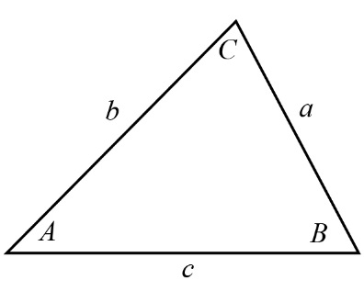  The lengths of the sides of a triangle are related to the cosine of one of its angles by the equation $c^{2}=a^{2}+b^{2}-2ab\cos{C.}$  This is known as the cosine rule.  
Sine, cosine and tangent functions | Since each angle $θ$ measured anticlockwise from the positive $x$-axis determines a point $P$ on the unit circle, we will define  the cosine of $θ$ to be the $x$‐coordinate of the point $P$  the sine of $θ$ to be the $y$‐coordinate of the point $P$  the tangent of $θ$ is the gradient of the line segment $OP$.  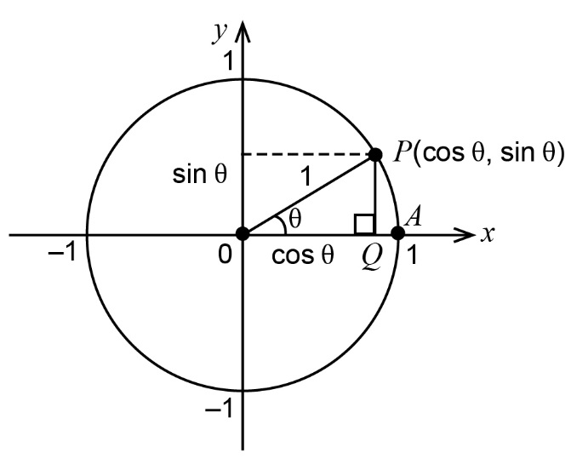
Counting and probability
Conditional probability | The probability that an event $A$ occurs can change if it becomes known that another event $B$ occurs. The new probability is known as a conditional probability and is written as $P\left(A | B\right).$ If $B$ has occurred, the sample space is reduced by discarding all outcomes that are not in the event $B.$ The new sample space, called the reduced sample space, is $B.$ The conditional probability of event $A$ is given by $P(A|B)=\frac{P(A∩B)}{P(B)}$ .
Independent events | Two events are independent if knowing that one occurs tells us nothing about the other. The concept can be defined formally using probabilities in various ways: events $A$ and $B$ are independent if $P(A∩B)=P(A)P(B)$, if $P\left(A | B\right)=P(A)$ or if $P\left(B\right)=P\left(B | A\right).$ For events $A$ and $B$with non-zero probabilities, any one of these equations implies any other.
Mutually exclusive | Two events are mutually exclusive if there is no outcome in which both events occur.
Pascal’s triangle | Pascal’s triangle is a triangular arrangement of binomial coefficients. The $n^{th}$ row consists of the binomial coefficients $\left(\begin{matrix}n \\ r\end{matrix}\right),$ for $0≤r≤n$, each interior entry is the sum of the two entries above it, and sum of the entries in the $n^{th}$ row is $2^{n}$  For example, 10 = 4 + 6.
Relative frequency | If an event $E$ occurs $r$ times when a chance experiment is repeated $n$ times, the relative frequency of $E$ is $\frac{r}{n}$.
Exponential functions
Algebraic properties of exponential functions | The algebraic properties of exponential functions are the index laws: $a^{x}a^{y}=a^{x+y}$, $a^{-x}=\frac{1}{a^{x}}$ , ${\left(a^{x}\right)}^{y}=a^{xy}$, ${ a}^{0}=1$, for any real numbers $x, y, \text{and} a$, with $a>0$.
Index laws | The index laws are the rules: $a^{x}a^{y}=a^{x+y}$, $a^{-x}=\frac{1}{a^{x}}$ , ${\left(a^{x}\right)}^{y}=a^{xy}$, ${ a}^{0}=1$, and ${\left(ab\right)}^{x}=a^{x}b^{x}$, for any real numbers $x, y, a \text{and} b$, with $a>0\text{ and }b>0$.
Arithmetic and geometric sequences and series
Arithmetic sequence | An arithmetic sequence is a sequence of numbers such that the difference of any two successive members of the sequence is a constant. For instance, the sequence  2, 5, 8, 11, 14, 17, …  is an arithmetic sequence with common difference 3.  If the initial term of an arithmetic sequence is $a$ and the common difference of successive members is $d$, then the $n$^{th} term $t_{n}$ of the sequence, is given by:  $t_{n}=a+\left(n-1\right)d$ for $n≥1$.  A recursive definition is  $t_{1}=a,t_{n+1}=t_{n}+d$, where $d$ is the common difference and $n≥1$.
Geometric sequence | A geometric sequence is a sequence of numbers where each term after the first is found by multiplying the previous one by a fixed number called the common ratio. For example, the sequence  3, 6, 12, 24, ...  is a geometric sequence with common ratio 2. Similarly the sequence  40, 20, 10, 5, 2.5, …  is a geometric sequence with common ratio $\frac{1}{2}$.  If the initial term of a geometric sequence is $a$ and the common ratio of successive members is $r$, then the $n$^{th} term $t_{n}$ of the sequence, is given by:  $t_{n}=ar^{n-1}$ for $n≥1$.  A recursive definition is  $t_{1}=a,t_{n+1}={rt}_{n}$ for $n≥1$ and where $r$ is the constant ratio.
Partial sums of a geometric sequence (geometric series) | The partial sum $S_{n}$ of the first $n$ terms of a geometric sequence with first term $a$ and common ratio $r$,  ${a, ar,ar}^{2}{, ……ar}^{n-1}…$ is $S_{n}= \frac{a(r^{n}-1)}{r-1}$, $r≠1$.  The partial sums form a sequence with $S_{n+1}= S_{n}+t_{n}$and $S_{1}= t_{1}$
Partial sum of an arithmetic sequence (arithmetic series) | The partial sum $S_{n}$ of the first $n$ terms of an arithmetic sequence with first term $a$ and common difference $d$.  $a, a+d,a+2d,……,a+\left(n-1\right)d,…$…  is $S_{n}=\frac{n}{2}\left(a+t_{n}\right)=\frac{n}{2}\left(2a+\left(n-1\right)d\right)$ where $t_{n}$is the $n$^{th} term of the sequence.  The partial sums form a sequence with $S_{n+1}= S_{n}+t_{n} and S_{1}= t_{1}$
Partial sums of a sequence (series) | The sequence of partial sums of a sequence $t_{1, …,}t_{s…}$is defined by $S_{n}= t_{1}+...+t_{n}$
Introduction to differential calculus
Anti-differentiation | An anti-derivative, primitive or indefinite integral of a function $f(x)$ is a function $F(x)$ whose derivative is $f(x)$, i.e. $F^{'}(x)=f(x).$  The process of solving for anti-derivatives is called anti-differentiation.  Anti-derivatives are not unique. If $F(x)$ is an anti-derivative of $f\left(x\right),$ then so too is the function $F\left(x\right)+c$ where $c$ is any number. We write $\int{f\left(x\right)}dx=F\left(x\right)+c$ to denote the set of all anti-derivatives of $f\left(x\right).$ The number $c$ is called the constant of integration. For example, since $\frac{d}{dx}\left(x^{3}\right)=3x^{2},$ we can write $\int{3x^{2} dx=x^{3}+c}.$
Gradient (Slope) | The gradient of the straight line passing through points $\left(x_{1},y_{1}\right)$and $\left(x_{2},y_{2}\right)$is the ratio $\frac{y_{2}-y_{1}}{x_{2}-x_{1}}$. Slope is a synonym for gradient.
Linearity property of the derivative | The linearity property of the derivative is summarised by the equations:  $\frac{d}{dx}\left(ky\right)=k\frac{dy}{dx}$ for any constant $k$ and $\frac{d}{dx}\left(y_{1}+y_{2}\right)=\frac{dy_{1}}{dx}+\frac{dy_{2}}{dx}$.
Local and global maximum and minimum | A stationary point on the graph $y=f(x)$ of a differentiable function is a point where $f'\left(x\right)=0$.  We say that $f(x_{0})$ is a local maximum of the function $f(x)$ if $f(x)≤f(x_{0})$ for all values of $x$ near $x_{0}$. We say that $f(x_{0})$ is a global maximum of the function $f(x)$ if $f(x)≤f(x_{0})$ for all values of $x$ in the domain of $f$.  We say that $f(x_{0})$ is a local minimum of the function $f(x)$ if $f(x)≥f(x_{0})$ for all values of $x$ near $x_{0}$. We say that $f(x_{0})$ is a global minimum of the function $f(x)$ if $f(x)≥f(x_{0})$ for all values of $x$ in the domain of $f$.
Secant | A secant of the graph of a function is the straight line passing through two points on the graph. The line segment between the two points is called a chord.
Simple polynomial | A simple polynomial is one which is easily factorised and whose stationary points may be easily determined using traditional calculus techniques.
Tangent line | The tangent line (or simply the tangent) to a curve at a given point $P$ can be described intuitively as the straight line that "just touches" the curve at that point. At $P$ where the curve meets the tangent, the curve has "the same direction" as the tangent line. In this sense, it is the best straight-line approximation to the curve at the point $P$.

